**LIBS as a Rapid Diagnostic to Ensure Food Safety**

Laser-Induced Breakdown Spectroscopy (LIBS) is a field deployable technology that has the potential to address the need for a rapid (seconds to minutes) and fairly comprehensive diagnostic for detection of pathogens in food products such as beef, poultry, milk, eggs and cheese as well as in the food manufacturing environment (e.g. to assess cleanliness).

In LIBS, laser pulses are focused in/on a sample to ablate and vaporize a small sample mass and excite the resulting atoms and simple molecules to emit light. Recent advances in data processing capabilities have lead to the successful application of chemometric data analysis methods to the LIBS spectrum to identify chemical compounds and pathogens on complex substrates. For these analyses the entire spectrum is treated as a “fingerprint” for the compound(s) or pathogen(s) of interest for the measurement conditions and samples included in the analysis.

Compared to current analysis methods for biological targets, the potential advantages of LIBS include: rapid analysis for targeted species and strains (<2 min for a comprehensive analysis); minimal or no sample preparation required; detection of targeted species and strains as contaminants in various matrices; simultaneous detection of multiple contaminants (elimination of separate tests for individual contaminants); analysis without a requirement for chemicals or consumables; use in many environments through the use of compact and rugged components available as commercial items (use that is not restricted to laboratory conditions); and automated analysis through instrument control and analysis software (operation and analysis with little training).

Shown below are (left) LIBS interrogation of a sample and (right) a prototype instrument developed by ARA to demonstrate the analysis process and the speed of detection. This instrument is calibrated specifically to differentiate uncontaminated eggshell from eggshell contaminated with *Salmonell*a or *E. coli*. This prototype provides analysis results in approximately 30 seconds following initiation of the test.

 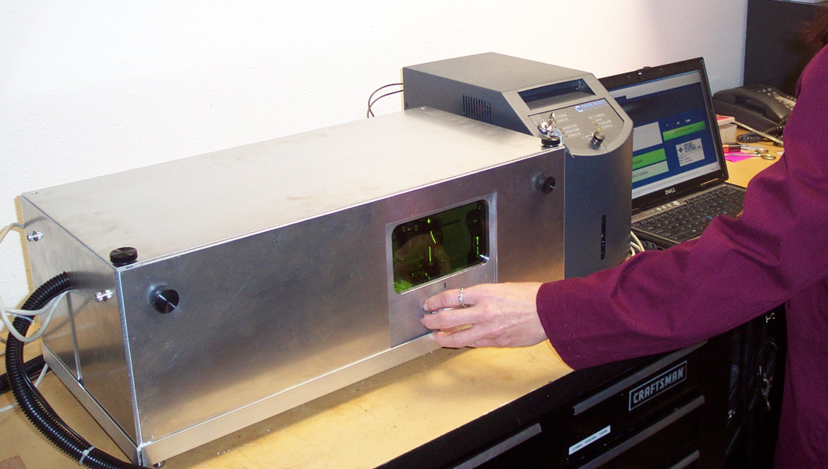

Each detection application is unique and the first step in determining the potential of the technique is a proof-of-concept study in which detection capabilities for well-controlled analysis conditions is demonstrated. Given good results from the proof-of-concept study, the next step is fabrication of a LIBS instrument for the application. Once the instrument is built, a calibration pilot is run on “real world” samples to calibrate the instrument and fine-tune performance. In this pilot, run after the detection algorithm is initially created, the detection algorithm results using production material are compared to those obtained from traditional analysis methods and the detection algorithms are adjusted to reach desired detection fidelity.